The folder “IMU GENERATED OUTPUTS” contains some simulated outputs to test your algorithm with. For every trajectory, you can find the IMU generated outputs in the exchange format, as well as some figures representing the trajectory from which the IMU outputs were generated. The IMU outputs with and without noise are given.

**TRAJECTORY 1 :**

This folder includes a static profile, where the IMU sensors are still, during 600 seconds.

The starting point of the trajectory is [0, 0, 0] in the LLA-frame, or [6378137m, 0, 0] in the ECEF-frame. The initial orientation of the IMU is : heading = 0°N, roll = 0°, yaw = 0°.

The IMU outputs are generated at 100Hz without interruption.

The accelerometers are embedded in the body frame defined by the figure below. The gyroscopes are aligned with the ECEF0 frame (the ECEF frame at the starting epoch of the scenario)

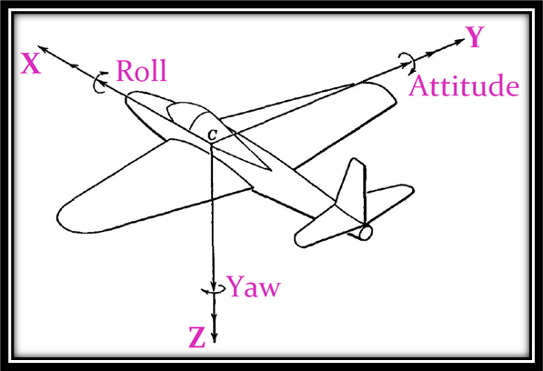body frame used for accelerometer alignment, the three accelerometers are respectively aligned with the X, Y, and Z axis.

**TRAJECTORY 2 :**

This folder contains a straight line trajectory (following the Earth curvature), where the IMU is said to be fixed on a car, with its X-axis aligned with the trajectory, and its Z-axis in the direction of the local gravity vector (as defined by the figure above). The trajectory lasts 600 seconds and the movement starts at about 60 seconds and stops at about 540 seconds. The maximum velocity of the IMU sensors lies around 5.14 m/s.

The starting point of the trajectory is [0, 0, 0] in the LLA-frame, or [6378137m, 0, 0] in the ECEF-frame, with a zero velocity in the ECEF-frame. The initial orientation of the IMU is : heading = 0°N, roll = 0°, yaw = 0°.

The ending point of the trajectory is [0.0215, 0, 0] in the LLA-frame, or [6378137m, 0, 0] in the ECEF-frame, with a zero velocity in the ECEF-frame.

The IMU outputs are generated at 50Hz without interruption.

The accelerometers are embedded in the body frame defined by the figure above. The gyroscopes are aligned with the ECEF0 frame (the ECEF frame at the starting epoch of the scenario)

**TRAJECTORY 3 :**

This folder contains moving IMU outputs performing a right turn,a left turn and finally a 360°-turn from right (following the Earth curvature), where the IMU is said to be fixed on a car, with its X-axis aligned with the trajectory, and its Z-axis in the direction of the local gravity vector. The trajectory lasts 600 seconds and the movement starts at about 60 seconds and stops at about 580 seconds.

The starting point of the trajectory is [0, 0, 0] in the LLA-frame, or [6378137m, 0, 0] in the ECEF-frame, with a zero velocity in the ECEF-frame. The initial orientation of the IMU is : heading = 0°N, roll = 0°, yaw = 0°.

The IMU outputs are generated at 100Hz without interruption.

The accelerometers are embedded in the body frame defined by the figure below. The gyroscopes are aligned with the ECEF0 frame (the ECEF frame at the starting epoch of the scenario)

**TRAJECTORY 4 :**

This folder contains moving IMU outputs performing a right turn,a left turn and finally a 360°-turn from right (following the Earth curvature), where the IMU is said to be fixed on a car, with its X-axis aligned with the trajectory, and its Z-axis in the direction of the local gravity vector. This trajectory is the same as the trajectory 3, but with higher velocity. The trajectory lasts 600 seconds and the movement starts at about 60 seconds and stops at about 580 seconds.

The starting point of the trajectory is [0, 0, 0] in the LLA-frame, or [6378137m, 0, 0] in the ECEF-frame, with a zero velocity in the ECEF-frame. The initial orientation of the IMU is : heading = 0°N, roll = 0°, yaw = 0°.

The IMU outputs are generated at 50Hz without interruption.

The accelerometers are embedded in the body frame defined by the figure below. The gyroscopes are aligned with the ECEF0 frame (the ECEF frame at the starting epoch of the scenario)

**TRAJECTORY 5 :**

This folder contains moving IMU outputs performing a right then a left turn at a constant altitude of 500ft, where the IMU is said to be fixed on an airplane, with its XYZ frame given by the figure below. This trajectory is different from the trajectory 4 because the aircraft is banking during the turns.The trajectory lasts 600 seconds and the movement starts at about 60 seconds and stops at about 580 seconds.

The starting point of the trajectory is [0, 0, 500ft] in the LLA-frame, or [6378289.4m, 0, 0] in the ECEF-frame, with a zero velocity in the ECEF-frame. The initial orientation of the IMU is : heading = 0°N, roll = 0°, yaw = 0°.

The IMU outputs are generated at 50Hz without interruption.

The accelerometers are embedded in the body frame defined by the figure below. The gyroscopes are aligned with the ECEF0 frame (the ECEF frame at the starting epoch of the scenario)



**TRAJECTORY 6 :**

This folder contains moving IMU outputs performing a climb then a descent between 0ft and 1000ft,, where the IMU is said to be fixed on an airplane, with its XYZ frame given by the aircraft body frame. The trajectory lasts 420 seconds and the movement starts at about 60 seconds and stops at about 420 seconds.

The starting point of the trajectory is [0, 0, 0] in the LLA-frame, or [6378137m, 0, 0] in the ECEF-frame, with a zero velocity in the ECEF-frame. The initial orientation of the IMU is : heading = 90°N, roll = 0°, yaw = 0°.

The IMU outputs are generated at 50Hz without interruption.

The accelerometers are embedded in the body frame defined by the figure below. The gyroscopes are aligned with the ECEF0 frame (the ECEF frame at the starting epoch of the scenario)

**TRAJECTORY 7 :**

This folder contains moving IMU outputs performing a whole flight, where the IMU is said to be fixed on an airplane, with its XYZ frame given by the aircraft body frame. The trajectory lasts about 2 hours.

The starting point of the trajectory is [45°, 0, 0] in the LLA-frame, or [4517590.88m, 0., 4487348.4m] in the ECEF-frame, with an initial velocity of [-1.11836128e+00 3.70721582e-35 1.11835888e+00] m/s in the ECEF-frame. The initial orientation of the IMU is : heading = 90°N, roll = 0°, yaw = 0°.

The IMU outputs are generated at 20Hz without interruption.

The accelerometers are embedded in the body frame defined by the figure below. The gyroscopes are aligned with the ECEF0 frame (the ECEF frame at the starting epoch of the scenario)